|  |  |  |  |
| --- | --- | --- | --- |
| 2 | | 39,384.0 | |
| NUMERO DE FRONTERAS | | ENERGIA AGREGADA | |
|  | | | |
|  | |  | |
| CONTRATO | | VENCIMIENTO CONTRATO | |
|  | | | |
| 6,634,350 | 35 | | 282,990 |
| INGRESO 2019 | DÍAS CERTIFICADOS 2019 | | ENERGIA RESPALDADA 2019 |
|  | | | |
| 77,066,219 | 198 | | 2,915,797 |
| INGRESO 2020 | DÍAS CERTIFICADOS 2020 | | ENERGIA RESPALDADA 2020 |
|  | | | |
| 46,789,062 | 69 | | 1,968,564 |
| INGRESO 2021 | DÍAS CERTIFICADOS 2021 | | ENERGIA RESPALDADA 2021 |

|  |
| --- |
| **COLOMBINA TULUA**  USUARIO |

|  |
| --- |
| **Mateo Porras**  Ejecutivo de cuenta |

|  |
| --- |
| **Francisco Pizarro / Gerente de proyectos & Administración Energética / fpizarro@colombina.com**  PUNTO FOCAL |

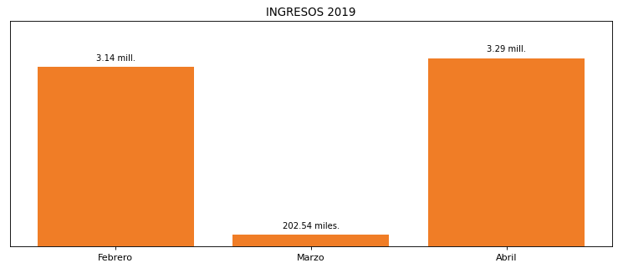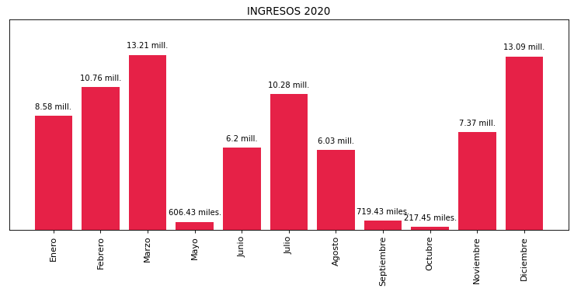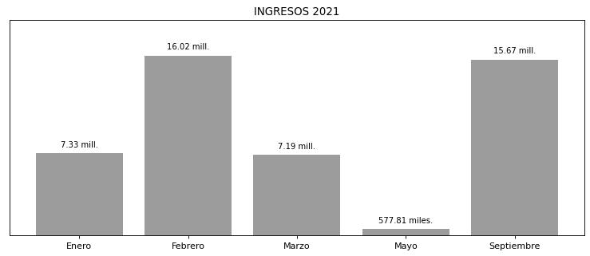

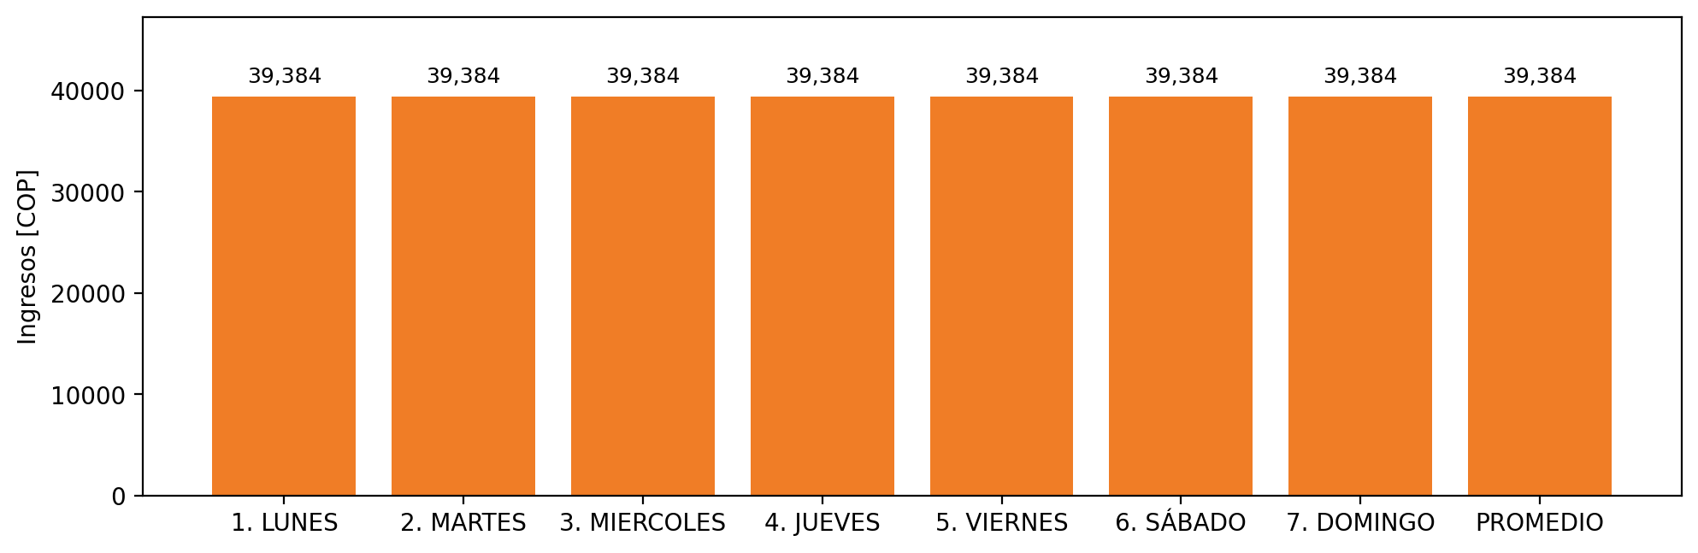

|  |  |  |  |  |  |  |  |  |  |  |
| --- | --- | --- | --- | --- | --- | --- | --- | --- | --- | --- |
| **FRONTERA** | **COD SIC** | **PREDIO** | **FRT DDV** | **TIPO DDV** | **PROMEDIO** | **PRÓXIMA ACTUALIZACIÓN** | **MARGEN DE ERROR** | **ÚLTIMA PRUEBA DDV** | **DÍAS PARTICIPACIÓN** | **FECHA REFERENCIA PRÓXIMA PRUEBA DDV** |
| COLOMBINA S.A. - 1 | Frt26193 | Prd01514 | Frt35936 | GPE | 24,984 | 2023-04-15 | NO APLICA | 2021-09-04 | 17.0 | 2022-01-22 |
| COLOMBINA S.A. - 2 | Frt26193 | Prd01514 | Frt41381 | GPE | 24,984 | 2022-04-15 | NO APLICA | 2021-09-04 | 17.0 | 2022-01-22 |